Industrial Internship Report on
”Banking Information System”
Prepared by
Nagulan.R
J.N.N Institute of Engineering

Executive Summary
This report provides details of the Industrial Internship provided by upskill Campus and The IoT Academy in collaboration with Industrial Partner UniConverge Technologies Pvt Ltd (UCT).
This internship was focused on a project/problem statement provided by UCT. We had to finish the project including the report in 6 weeks’ time.
My project was the "Banking Information System", a Core Java console application that simulates the basic operations of a bank, including creating and managing customer accounts, performing deposits and withdrawals, checking balances and viewing transaction history, with all data handled through Java's object-oriented and file-handling features.
This internship gave me a very good opportunity to get exposure to Industrial problems and design/implement solution for that. It was an overall great experience to have this internship.

TABLE OF CONTENTS
1 Preface 3
2 Introduction 4
2.1 About UniConverge Technologies Pvt Ltd 4
2.2 About upskill Campus 8
2.3 Objective 9
2.4 Reference 9
2.5 Glossary 10
3 Problem Statement 11
4 Existing and Proposed solution 12
5 Proposed Design/ Model 13
5.1 High Level Diagram (if applicable) 13
5.2 Low Level Diagram (if applicable) 13
5.3 Interfaces (if applicable) 13
6 Performance Test 14
6.1 Test Plan/ Test Cases 14
6.2 Test Procedure 14
6.3 Performance Outcome 14
7 My learnings 15
8 Future work scope 16

Preface
This report summarizes the six-week Industrial Internship that I underwent as part of the Free Summer Internship in Python/Core Java program offered by upSkill Campus (USC) and The IoT Academy, in association with Industry Partner UniConverge Technologies Pvt. Ltd. (UCT).
Internships like this play an important role in a student's career development, as they bridge the gap between classroom learning and real, industry-oriented problem solving, and give exposure to how software projects are actually built and delivered.
My project/problem statement was to design and develop a "Banking Information System" using Core Java, a console-based application that allows users to create bank accounts, deposit and withdraw funds, check account balances and view transaction history in a simple, menu-driven interface.
I am thankful to USC and UCT for providing this opportunity to work on a real, structured project and to learn the complete lifecycle of software development within a defined timeline.
The program was planned over 6 weeks, starting with orientation and learning resources, followed by weekly milestones for design, coding, testing and documentation, culminating in the final project and report submission.
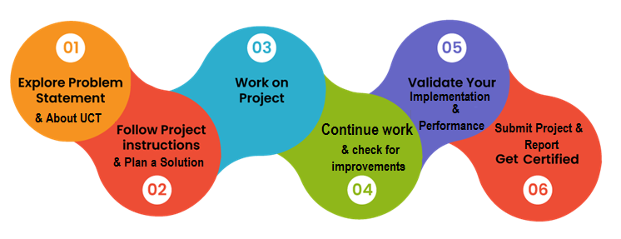
Overall, this internship was a great learning experience. I gained hands-on experience in Core Java programming, object-oriented design and basic file/data handling, and I also learned how to plan work over weekly milestones and document a project professionally.
I would like to thank the entire team at upSkill Campus, The IoT Academy and UniConverge Technologies for their guidance and support, and my faculty and mentors at J.N.N Institute of Engineering for their continuous encouragement throughout this internship.
To my juniors and peers, I would encourage you to take up such internships seriously, start early, and use the weekly milestones to stay on track — the practical exposure they provide is genuinely valuable for your career.

Introduction

About UniConverge Technologies Pvt Ltd
A company established in 2013 and working in Digital Transformation domain and providing Industrial solutions with prime focus on sustainability and RoI.
For developing its products and solutions it is leveraging various Cutting Edge Technologies e.g. Internet of Things (IoT), Cyber Security, Cloud computing (AWS, Azure), Machine Learning, Communication Technologies (4G/5G/LoRaWAN), Java Full Stack, Python, Front end etc.
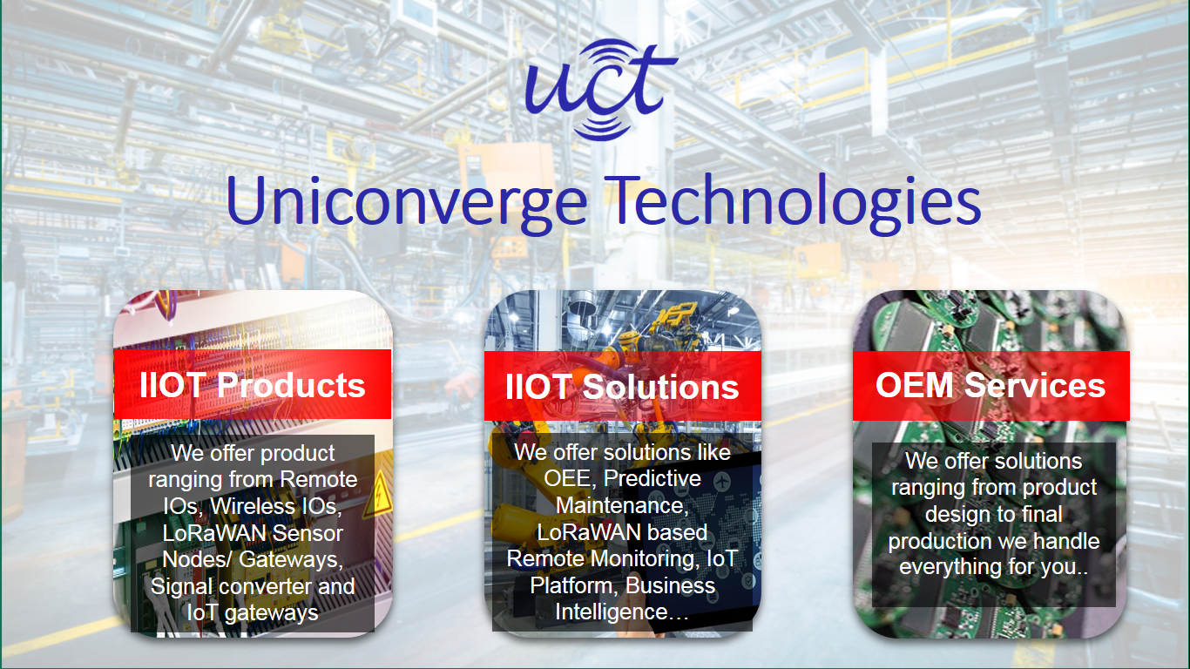
- UCT IoT Platform ()
UCT Insight is an IOT platform designed for quick deployment of IOT applications on the same time providing valuable “insight” for your process/business. It has been built in Java for backend and ReactJS for Front end. It has support for MySQL and various NoSql Databases.
- It enables device connectivity via industry standard IoT protocols - MQTT, CoAP, HTTP, Modbus TCP, OPC UA
- It supports both cloud and on-premises deployments.
It has features to
• Build Your own dashboard
• Analytics and Reporting
• Alert and Notification
• Integration with third party application(Power BI, SAP, ERP)
• Rule Engine

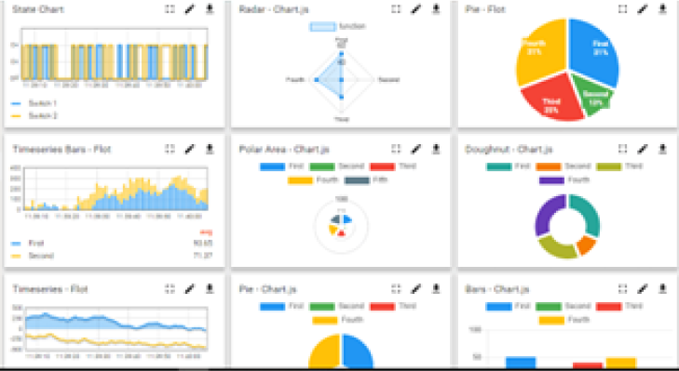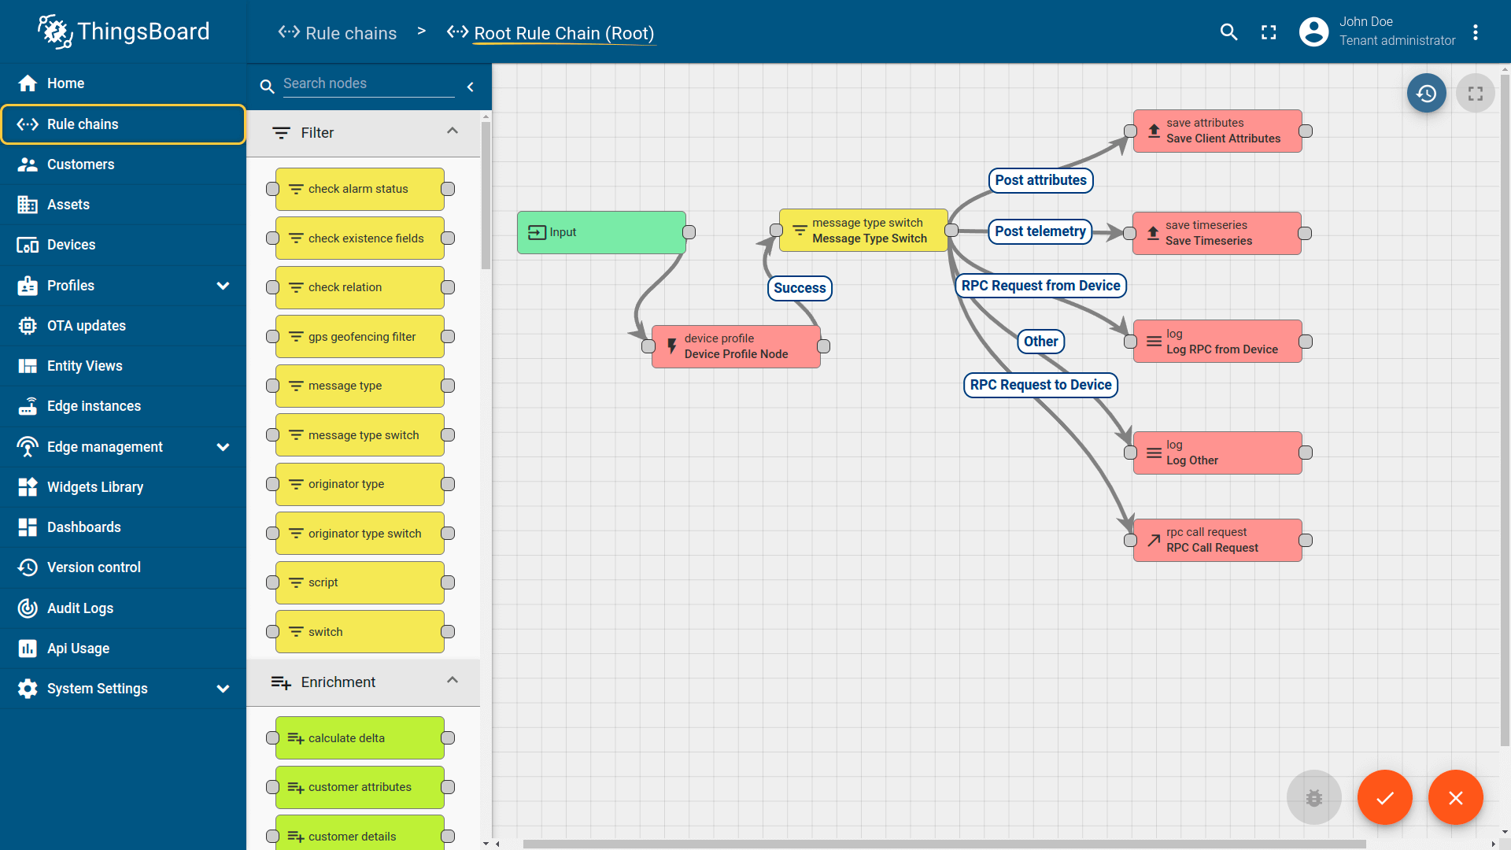

- Smart Factory Platform ()
Factory watch is a platform for smart factory needs.
It provides Users/ Factory
- with a scalable solution for their Production and asset monitoring
- OEE and predictive maintenance solution scaling up to digital twin for your assets.
- to unleased the true potential of the data that their machines are generating and helps to identify the KPIs and also improve them.
- A modular architecture that allows users to choose the service that they what to start and then can scale to more complex solutions as per their demands.
Its unique SaaS model helps users to save time, cost and money.
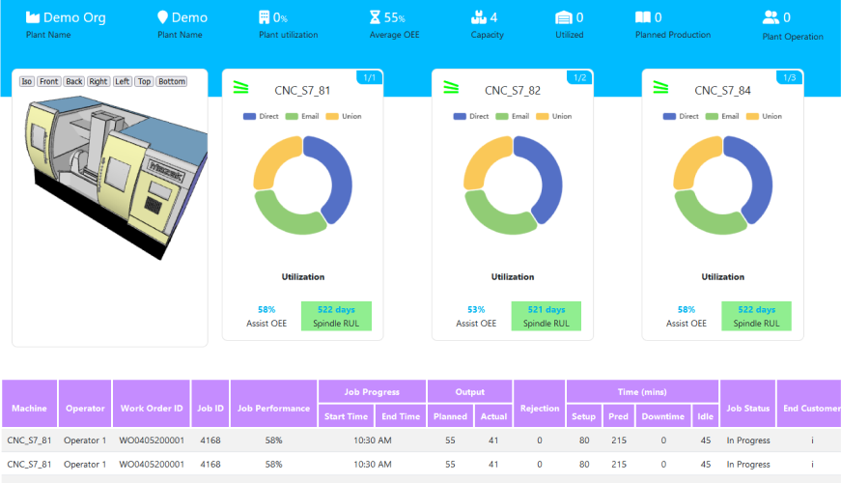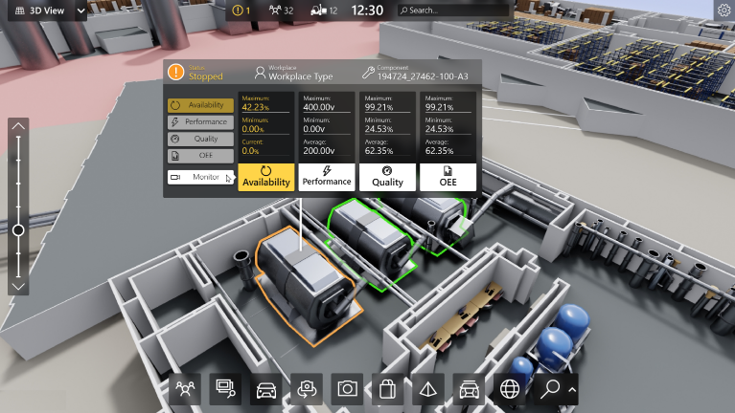

- 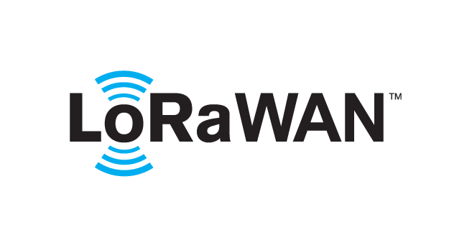 based Solution
UCT is one of the early adopters of LoRAWAN teschnology and providing solution in Agritech, Smart cities, Industrial Monitoring, Smart Street Light, Smart Water/ Gas/ Electricity metering solutions etc.
- Predictive Maintenance
UCT is providing Industrial Machine health monitoring and Predictive maintenance solution leveraging Embedded system, Industrial IoT and Machine Learning Technologies by finding Remaining useful life time of various Machines used in production process.
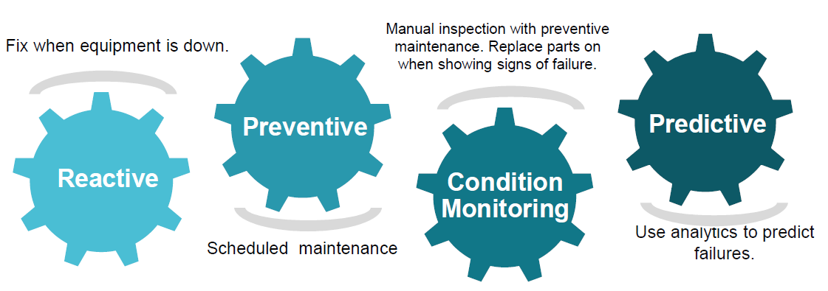

About upskill Campus (USC)
upskill Campus along with The IoT Academy and in association with Uniconverge technologies has facilitated the smooth execution of the complete internship process.
USC is a career development platform that delivers personalized executive coaching in a more affordable, scalable and measurable way.




Seeing need of upskilling in self paced manner along-with additional support services e.g. Internship, projects, interaction with Industry experts, Career growth Services
https://www.upskillcampus.com/
upSkill Campus aiming to upskill 1 million learners in next 5 year

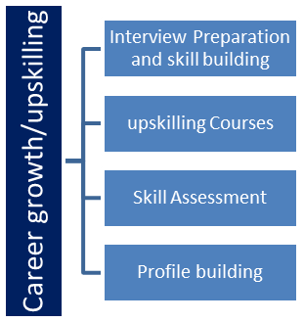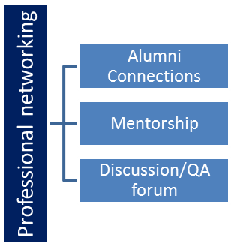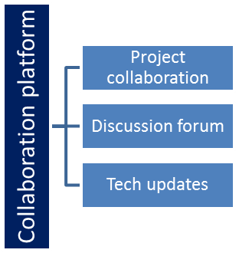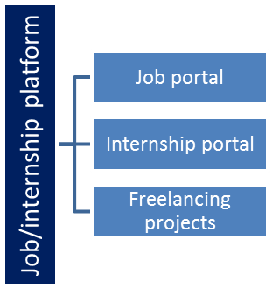

The IoT Academy
The IoT academy is EdTech Division of UCT that is running long executive certification programs in collaboration with EICT Academy, IITK, IITR and IITG in multiple domains.

Objectives of this Internship program
The objective for this internship program was to
☛ get practical experience of working in the industry.
☛ to solve real world problems.
☛ to have improved job prospects.
☛ to have Improved understanding of our field and its applications.
☛ to have Personal growth like better communication and problem solving.

Reference
[1]
[2]
[3]

Glossary
Terms | Acronym

Problem Statement
In the assigned problem statement
Banks and financial institutions need a reliable way to manage customer accounts and day-to-day transactions such as deposits, withdrawals, and balance enquiries. Manually maintaining this information is slow and error-prone. The problem statement was to design and implement a "Banking Information System" using Core Java that allows a bank employee/user to create new customer accounts, perform deposit and withdrawal operations with proper validation, check account balances, and view transaction history — all through a simple, menu-driven console application, with account and transaction data persisted so it is not lost between sessions.

Existing and Proposed solution

Existing commercial banking software (like Core Banking Solutions used by real banks) are large, feature-rich enterprise systems that handle millions of accounts, integrate with ATMs, UPI, and other channels, and involve significant licensing cost and infrastructure. They are excellent for production use but are far too complex to study, modify or learn from as a beginner project, and their source code is proprietary.
My proposed solution is a lightweight, console-based "Banking Information System" built in Core Java, which implements the core operations of a bank — account creation, deposit, withdrawal, balance enquiry, and transaction history — using classes and objects to represent customers and accounts, and file handling to store data persistently between runs.
The value addition of this project is that it demonstrates, in a simple and understandable way, how the fundamental building blocks of a real banking application (object-oriented design, input validation, and persistent storage) work together, making it a good learning foundation that can later be extended with a database backend, a GUI, or multi-user support.

Code submission (Github link)
https://github.com/<your-github-username>/upskillcampus/blob/main/BankingInformationSystem.java

Report submission (Github link) : first make placeholder, copy the link.
https://github.com/<your-github-username>/upskillcampus/blob/main/BankingInformationSystem_NagulanR_USC_UCT.pdf

Proposed Design/ Model

The Banking Information System is designed around a simple, layered flow: the user interacts with a console menu, the menu choice is routed to the relevant operation (create account, deposit, withdraw, balance enquiry, or view transaction history), the operation is performed on an in-memory Account object, and the updated data is written back to a file so that it persists between runs.

High Level Diagram (if applicable)
User (Console Input) → Main Menu → Operation Handler (Create Account / Deposit / Withdraw / Balance Enquiry / Transaction History) → Account/Customer Class (business logic and validation) → File Storage (persists account and transaction data) → Output back to Console.

Figure 1: HIGH LEVEL DIAGRAM OF THE SYSTEM

Low Level Diagram (if applicable)
The application uses a small set of classes: a Customer/Account class holding fields such as account number, holder name, and balance along with methods for deposit(), withdraw() and getBalance(); a Transaction class that records each operation with a type, amount and timestamp; a FileHandler/DataStore class responsible for reading and writing account and transaction data to disk; and a Main/Menu class that drives the console interface and calls the appropriate methods based on user input, with basic validation (e.g., rejecting negative amounts or withdrawals exceeding the available balance).

Interfaces (if applicable)
The only interface for this system is a text-based console menu. The data flow is: user selects an option from the menu → input is validated (e.g., numeric amounts, existing account numbers) → the corresponding operation is executed on the account data held in memory → the result is written to a local file (acting as simple persistent storage in place of a database) → a confirmation or the requested information (balance, transaction history) is displayed back to the user on the console.

Performance Test

This is very important part and defines why this work is meant of Real industries, instead of being just academic project.
Here we need to first find the constraints.
How those constraints were taken care in your design?
What were test results around those constraints?
Constraints can be e.g. memory, MIPS (speed, operations per second), accuracy, durability, power consumption etc.
For a lightweight console application like this, the main constraints considered were data accuracy (correct balance updates), input validation (rejecting invalid amounts or non-existent account numbers) and durability (ensuring data is not lost between program runs). These were addressed by validating every deposit/withdrawal amount before updating the balance, and by writing account and transaction data to a file immediately after every successful operation. Since the application is not multi-user, concerns like concurrent access or high transaction throughput (MIPS/speed) were out of scope for this project but are noted as recommendations for future work if the system is scaled up with a database and multiple users.

Test Plan/ Test Cases
Key test cases included: (1) creating a new account with valid details, (2) depositing a valid positive amount and verifying the balance increases correctly, (3) attempting to withdraw more than the available balance and verifying it is rejected, (4) depositing/withdrawing a negative or zero amount and verifying it is rejected, (5) checking the balance and transaction history of an existing account, and (6) restarting the application and confirming previously saved account data is still available.

Test Procedure
Each test case was executed manually by running the application from the console, choosing the relevant menu option, entering the required inputs, and observing the output/updated balance displayed on screen. The underlying data file was also inspected after each run to confirm that account and transaction records were correctly written and updated.

Performance Outcome
All the above test cases passed as expected: valid deposits and withdrawals correctly updated the balance, invalid operations (negative amounts, over-withdrawal) were correctly rejected with an appropriate message, and account data persisted correctly across multiple runs of the application, confirming that the file-based storage mechanism works reliably for the intended single-user, low-volume use case.

My learnings

Through this internship, I strengthened my understanding of Core Java concepts such as classes, objects, encapsulation, and exception handling, and learned how to apply them to build a functioning application rather than just solving isolated problems. I also gained practical experience with file handling for data persistence, structuring a project with clean, modular code, and following a professional documentation and reporting process. Working within a 6-week timeline also improved my time management and planning skills. Overall, this experience has strengthened my fundamentals for future Java-based development and internship/placement opportunities.

Future work scope

Due to the limited time available, the current version stores data in a flat file and supports only a single user at a time. In the future, this project can be extended by connecting it to a proper database (such as MySQL) for more robust and scalable storage, adding a graphical user interface (using JavaFX or a web front-end) instead of the console menu, implementing multi-user login with authentication, adding features like fund transfer between accounts and interest calculation, and introducing better security measures such as password hashing and transaction encryption.

